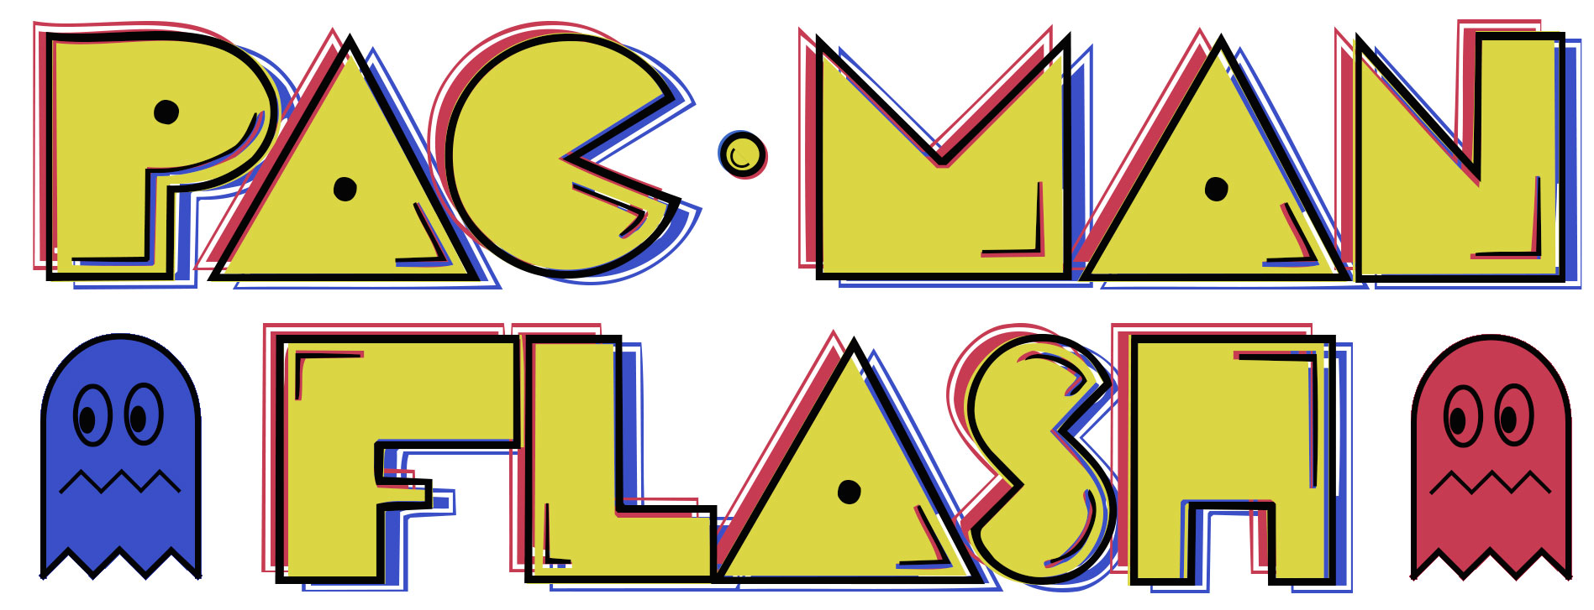User Guide

Pac-Man Flash is a new version of Pac-Man, but with a few new changes. Instead of the ghosts chasing Pac-Man, the ghosts will randomly appear on the board and try to prevent Pac-Man from eating all the dots. If a ghost gets Pac-Man, the game is over and the user loses. If Pac-Man eats all the dots without running into a ghost, the user wins! The goal of the game if to move Pac-Man around the screen to eat as many pellets as possible, all while avoiding the ghosts.

Below is a picture of the dialog box to start the game. In order to begin, the user must hit the ‘Start Game’ button. If the user does not want to play the game, they can just hit the ‘Exit’ button.

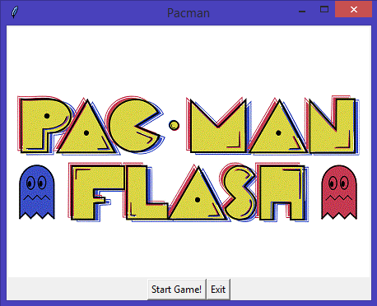

There are four ghosts in the game; their names and personalities are as follows.

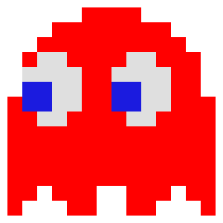

Victoria is the red ghost. She is sassy and adventurous. She likes coffee and dislikes people who walk slowly.



Nick is the orange ghost. He is spacey and quiet. He likes peanut butter and jelly and dislikes bees and mosquitoes.



Margie is the pink ghost. She is cheerful and energetic. She likes listening to music and dislikes scary movies.



Ryan is the blue ghost. He is spontaneous and carefree. He likes Magic: the Gathering and dislikes rap music.

Using the arrow keys, the user can move Pac-Man around the board. If the user hits the ‘up’ arrow, Pac-Man will move up. If the user hits the ‘down’ arrow Pac-Man will move down. If the user hits the ‘left’ arrow Pac-Man will move left. If the user hits the ‘right’ arrow Pac-Man will move right.

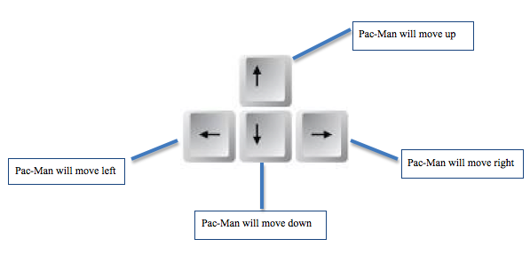Below is a picture of the board during game play.

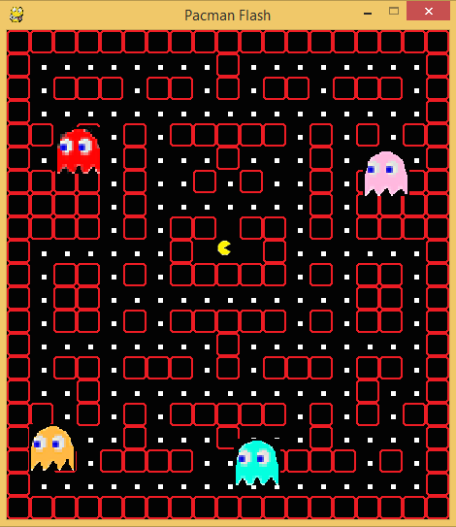

If the user loses, a window will display the score and an ‘Okay’ button. The score displays the amount of pellets Pac-Man has eaten, and the ‘Okay’ button will exit the program. The picture below shows the window after the user lost after eating 14 pellets.

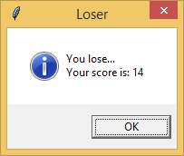

If the user wins, a window will display a message saying ‘You Win!’ and an ‘Okay’ button. The ‘Okay’ button will exit the program.

